 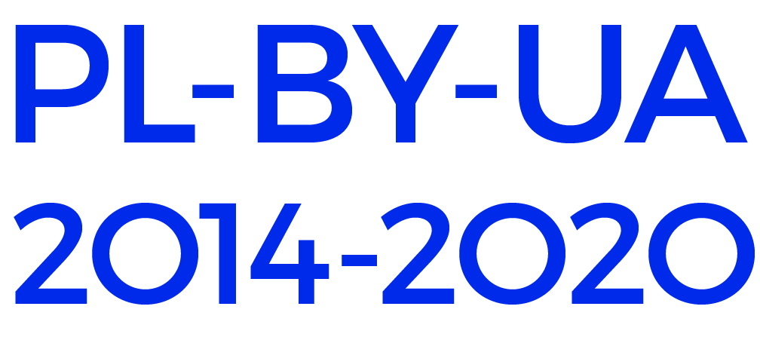

CROSS-BORDER EDUCATIONAL CAMPAIGN FOR SCHOOLS

WITHIN EUROPEAN COOPERATION DAY 2018

HERITAGE AND ME

**THE APPLICATION FORM**

The application form should be sent by ordinary mail to the address or relevant PBU BO in your country AND by email to the email address of PBU BO. The deadline for the submission of applications is **16** **April 2018** as evidenced by the date of dispatch, the postmark or the date of the deposit slip.

THE APPLICANT

|  |  |
| --- | --- |
| NAME OF THE SCHOOL |  |
| ADDRESS OF THE SCHOOL |  |
| REGION |  |
| NAME OF THE HEAD OF THE SCHOOL |  |

THE TEAM

|  |  |
| --- | --- |
| NAME OF THE HEAD OF THE TEAM (TEACHER) |  |
| TELEPHONE OF THE HEAD OF THE TEAM |  |
| E-MAIL ADDRESS OF THE HEAD |  |
| NAME OF MEMBER 1 OF THE TEAM |  | AGE: |
| NAME OF MEMBER 2 OF THE TEAM |  | AGE: |
| NAME OF MEMBER 3 OF THE TEAM |  | AGE: |
| NAME OF MEMBER 4 OF THE TEAM |  | AGE: |

TASK 1

|  |
| --- |
|  |
| INTRODUCE YOUR TEAM   1. Make an interesting and attractive presentation of your team in any format (written text, ppt presentation, a short video). You may highlight talents and achievements of the members; tell about your school, your city/village, interesting projects/initiatives you have implemented, even your dreams and plans for the future. 2. Publish a text or provide a link to your presentation below /OR attach a file to you e-application. |

TASK 2

|  |
| --- |
|  |
| TAKE A SELFIE   1. Take a photo of yourself (your team or any of the members) with an interesting object of the past. Write a couple of sentences to justify your choice. 2. Publish the photo in social media with *#PBUheritage,* try to get as many likes as possible 3. Insert a link to the picture below 4. Print the photo out and attach to your paper application |

TASK 3

|  |
| --- |
| DESIGN YOUR OWN T-SHIRT   1. Think of the idea how the past makes a part of today’s life, why we should preserve our common heritage. Try to represent it visually. 2. Make a design of a T-shirt based on this idea, which is attractive, simple and has a clear message. You can use paints, markers or any other media. The suggested format is A4. 3. Attach the original picture to your paper application. |

I hereby agree that the ideas presented in this application form may be used in communication materials produced by the Cross-border Cooperation Programme Poland - Belarus - Ukraine 2007-2013 (website, publications).

I hereby agree to obtain consent from the parents/guardians of the children participating in the competition for any photographs/audio/video recordings taken during the Final Award Event for the purposes of the CBC Programme Poland - Belarus -Ukraine 2007-2013, to be published in print or electronic media, including the Internet.

Date, signature of the Headmaster

..........................