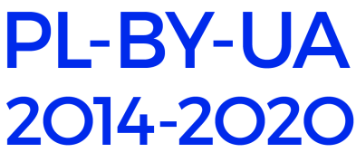

APPLICATION FORM
for participation in the
International Scientific Conference
“SECURITY OF THE AREA COVERED
BY THE CROSS-BORDER COOPERATION PROGRAMME
POLAND-BELARUS-UKRAINE”

Surname:
Name:
Scientific degree:
Academic status:
Position:
Organization (if apl):
Phone:
E-mail:
Thematic panel (please, underline) | 1. Physical and technical security  2. Public safety  3. Medical security  4. Economic security  5. Environmental safety
Subject of speech
Abstract of speech (up to 1000 characters with spaces) in Ukrainian, Polish or Russian languages.

The application form should be sent to the lviv@pbu2020.eu by June 17, 2019 at the latest.
Only completely filled in forms will be accepted.
Applications submitted after the expiration date will not be considered.
Abstracts that do not correspond to the stated topics of the conference will not be considered.
When selecting applications for participation in the Conference, priority will be given to those who, in their abstracts, have referred to the subjects of projects already implemented and those under implementation within the CBC Programme Poland-Belarus-Ukraine (please find links to project descriptions in invitation letter).

Your data shall be processed pursuant to Regulation (EC) No 45/2001 on the protection of individuals with regard to the processing of personal data by the Community institutions and bodies and on the free movement of such data. The data shall be processed solely for the purposes of the Scientific Conference organization.

